Drop Required User DB’s – (3) -- SQL Server.

--Below TSQL Script will kill all DB connections and delete all databases in the list.
--Ensure that before Dropping any DB, please take a Full DB Backup for safer side.
--Before dropping the below mentioned user databases.
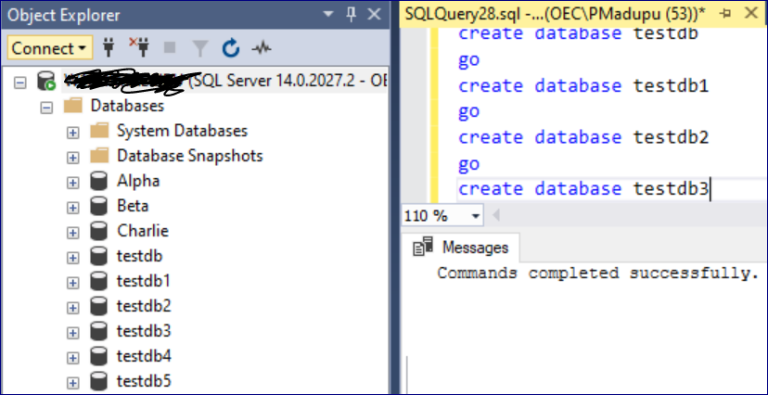
Case-1: Below TSQL Script will drop all User DB’s except System DB’s, Alpha, Beta, Charlie.

use master
go
declare @dbnames nvarchar(max)
declare @statement nvarchar(max)
set @dbnames = ''
set @statement = ''
select @dbnames = @dbnames + ',[' + name + ']' from sys.databases
where name
NOT IN ('master','model','msdb','tempdb') -- System Databases to keep
AND name NOT LIKE '%Alpha%' -- Database to keep
AND name NOT LIKE '%Beta%' -- Database to keep
AND name NOT LIKE '%Charlie%' -- Database to keep
if len(@dbnames) = 0
begin
print 'No Databases to Drop'
end
else
begin
set @statement = 'Drop Database ' + substring(@dbnames, 2, len(@dbnames))
print @statement
exec sp_executesql @statement
end
go
--After dropping the user databases which are not mentioned in above TSQL Script (Means not needed any more).
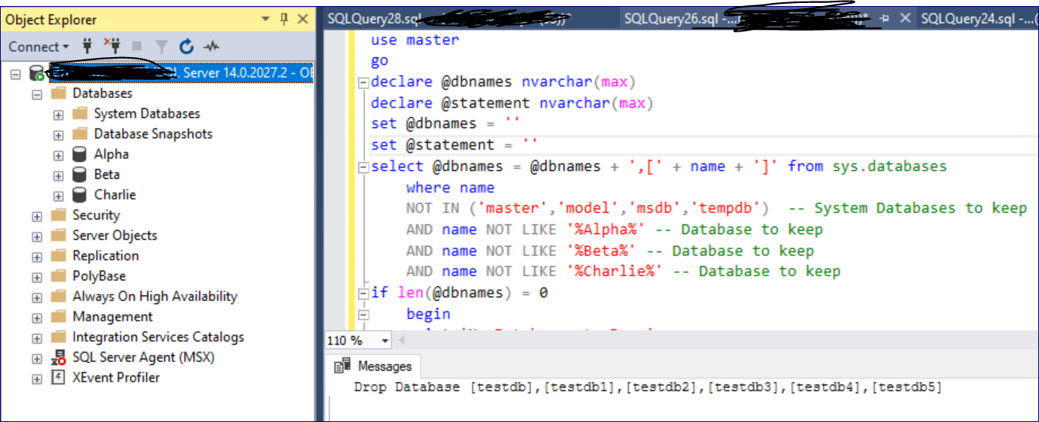
Case-2: Below TSQL Script will drop only mentioned User DB’s.

--Before dropping the mentioned user databases.

use master
go
declare @dbnames nvarchar(max)
declare @statement nvarchar(max)
set @dbnames = ''
set @statement = ''
select @dbnames = @dbnames + ',[' + name + ']' from sys.databases
where name IN ('testdb','testdb1','testdb2','testdb3','testdb4', 'testdb5') -- System Databases to keep
if len(@dbnames) = 0
begin
print 'No Databases to Drop'
end
else
begin
set @statement = 'Drop Database ' + substring(@dbnames, 2, len(@dbnames))
print @statement
exec sp_executesql @statement
end
go
--After dropping the mentioned user databases.
